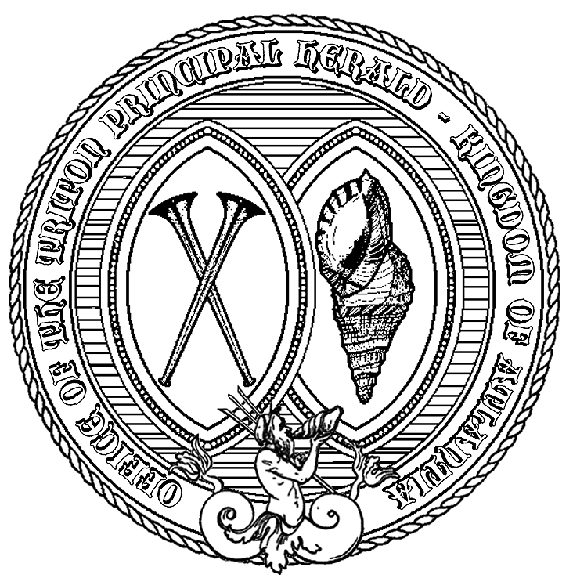

Basic Heraldry
Evaluation

Name: __________________________________________

Group: __________________________________________

Title: __________________________________________

Date Taken: ___________________ Score: ____________
SECTION A: Basic Armory

Identify the following shield areas:
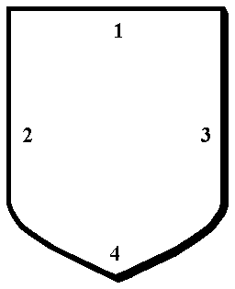

1. _______________ 2. _______________

3. _______________ 4. _______________

Give the common names for these shield shapes:

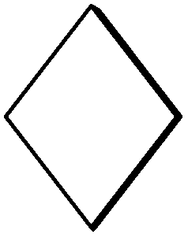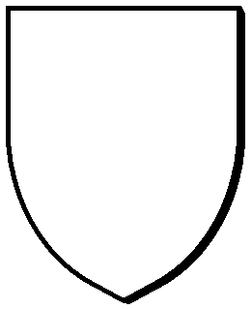

5. _______________ 6. _______________ 7. _______________

Identify the following:

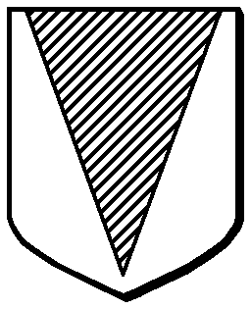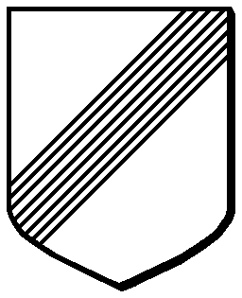

8. _______________ 9. _______________ 10. _______________ 11. _______________

Draw the following:

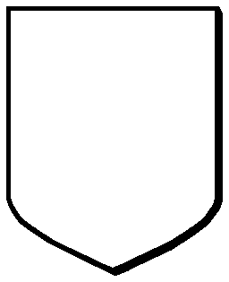
12. Chevron 13. Chief 14. Per Saltire 15. Flaunches 16. Per Pale

17. Bordure 18. Gyronny 19. Orle 20. Inescutcheon 21. Canton

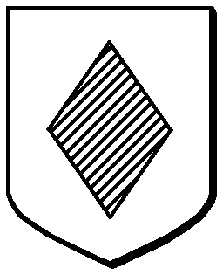

Identify the following charge: 23. Draw the charge shown
22. _______________ in #22 as voided:

SECTION B: Complex Lines of Division

Identify the following:
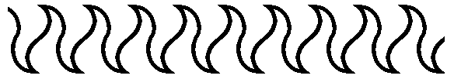

24. ____________________ 25. ____________________



26. ____________________ 27. ____________________

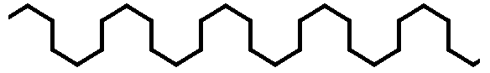

28. ____________________ 29. ____________________

Draw the following:

30. Wavy 31. Nebuly

32. Embattled 33. Indented

SECTION C: Tinctures

34. The general term for all hues is _______________________.

The two common subclasses are: _______________ and _______________.
35. 36.

List the tinctures by their heraldic term and then by their common name:

Heraldic term: Commonly referred to as:

37.
38.
39.
40.
41.
42.
43.

44. The heraldic representation of the skins of animals are the __________________.

Name any two examples of this group of heraldic representations: 45. __________________
46. __________________
SECTION D: Blazoning

Blazon the following devices:
47. _____________________________________________________________________________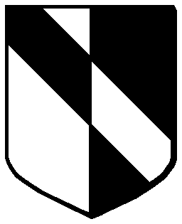

48. _____________________________________________________________________________

49. _____________________________________________________________________________

50. Blazon the arms of Atlantia: _______________________________________________________________

__________________________________________________________________________________________

__________________________________________________________________________________________

__________________________________________________________________________________________

Are the following blazons correct?

51. Per fess, or, and sable, on a bend three annulets counterchanged. [ ] Yes, it's correct

[ ] No, it's incorrect. The correct blazon should be: _________________________________________

__________________________________________________________________________________________

52. Argent, a water bouget sable and a point pointed azure. [ ] Yes, it's correct

[ ] No, it's incorrect. The correct blazon should be: _________________________________________

__________________________________________________________________________________________

53. Per chevron argent and gules, in chief two escallops gules and in base a tower argent. [ ] Yes, it's correct

[ ] No, it's incorrect. The correct blazon should be: _________________________________________

__________________________________________________________________________________________

54. Quarterly vert and azure, a seawolf, tailed as a fish, erect and sinister facing argent. [ ] Yes, it's correct

[ ] No, it's incorrect. The correct blazon should be: _________________________________________

__________________________________________________________________________________________
SECTION E: Protocol and Precedence

Use the following list for the matching questions below:

A. Viscountess E. Earl I. King
B. Baron F. Prince J. Crown Prince
C. Countess G. Consort K. Seneschal
D. Duke H. Viscount L. Peer

55. _______ Has no relevance to precedence.

56. _______ Highest male in precedence who is addressed as “Your Excellency”.

57. _______ General title of the person the victor of a Crown List fought for.

58. _______ Woman who has been Queen once.

59. _______ Highest male in precedence who is addressed as “Your Grace”.

60. _______ Properly addressed as “Your Royal Highness”.

61. _______ Title given to a male after ruling a Principality.

Using the numbers 1 – 6, place the following six titles in correct order of precedence.

62. ________ Viscount

63. ________ Duke

64. ________ Crown Prince

65. ________ King

66. ________ Earl

67. ________ Baron

68. List the three Orders of Peerage in the Society:

_________________________ _________________________ _________________________

SECTION F: Reporting and Submissions

69. Give the title for the Principal Herald of Atlantia: ______________________________________________

70. Name two of the kingdom Herald's deputies and their responsibilities:

___________________________________________ ___________________________________________

71. Which, if any, of the optional boxes on the name form must be checked? __________________

72. Is a black and white outline required for armory submissions? __________________

73. How often is a local herald required to report? __________________

74. Who receives copies of the local herald’s reports? __________________

75. What is a Domesday report? _______________________________________________________________
76. Who is required to do a Domesday report? __________________

77. Which of the following combinations of languages would not be allowed in a registered name? __________

A. English/Welsh B. Scottish/French C. English/Irish
D. Italian/Spanish E. Dutch/German F. Welsh/Japanese

78. For a name to be registered in the SCA, it must contain a given name and which of the list below? ________

A. a patronymic B. a nickname/byname C. a surname D. a locative
E. none of the above (A-D) F. all of the above (A-D) G. any one (or more) of the above (A-D)

79. What are the governing documents for heralds? ________________________________________________

80. Where can you find the list of name sources to avoid? ___________________________________________

81. What is the basic requirement for non-European name submissions? _______________________________

_________________________________________________________________________________________

82. Where can you find specific rulings that clarify the Rules for Submission? ___________________________

SECTION G: Courts and Awards

83. Who can hold a court? ____________________________________________________________________

84. Who is responsible for turning in the court report? ______________________________________________

85 .Who receives copies of the court report? ______________________________________________________

86. List two kingdom awards that carry an Award of Arms: __________________________________________

87. List two kingdom awards that carry a Grant of Arms? ___________________________________________

88. Is it possible to receive a Grant of Arms without an accompanying award? ___________________________

89. Name four baronies of Atlantia: ___________________________ ___________________________

___________________________ ___________________________

90. Name two of the baronial heralds’ titles: _________________________ ________________________

91. Name four baronial orders and what they're for:

-
-
-
-

92. List three things that are needed for a court: ___________________________________________________
SECTION H: Field and General Heraldry

93. Name one type of tourney that includes a march of precedence: ___________________________________

94. Name one type of tourney that typically requires personal heralds: _________________________________

95. What symbol identifies a herald at an event? __________________________________________________

96. Who do you work with on the tourney field? (Check all that apply)

[ ] Seneschal [ ] Nobility [ ] Chiurgeon [ ] Minister of the Lists
[ ] Marshal [ ] Exchequer [ ] Combatants [ ] Event Autocrat

97. What is Herald’s Point?

98. What is armory? _________________________________________________________________________

99. What does a device represent? ______________________________________________________________

100. What does a badge represent? _____________________________________________________________

Basic Heraldry Evaluation - Kingdom of Atlantia ©2011

